**R.PRANUSHA**

**192111023**

**CSA1557-CLOUD COMPUTING AND BIG DATA**

**EXP 15:Create a Cloning of a VM and Test it by loading the Previous Version/Cloned VM**

**Step 1:choose VM clone**

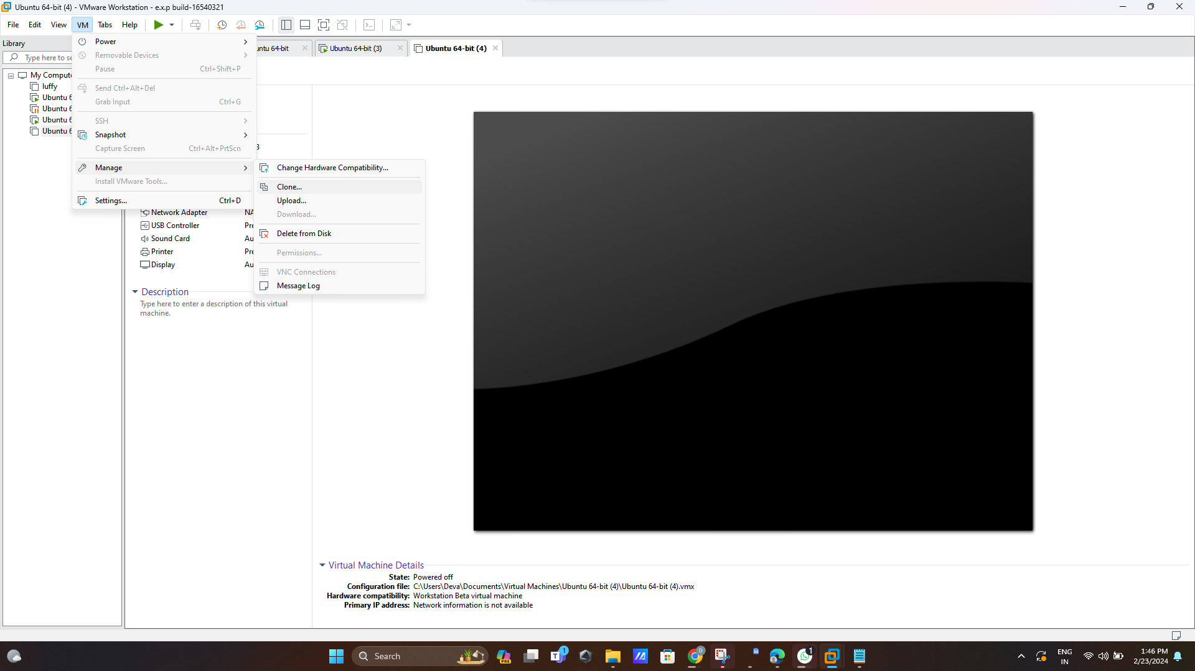

**Step 2:clone from current state**

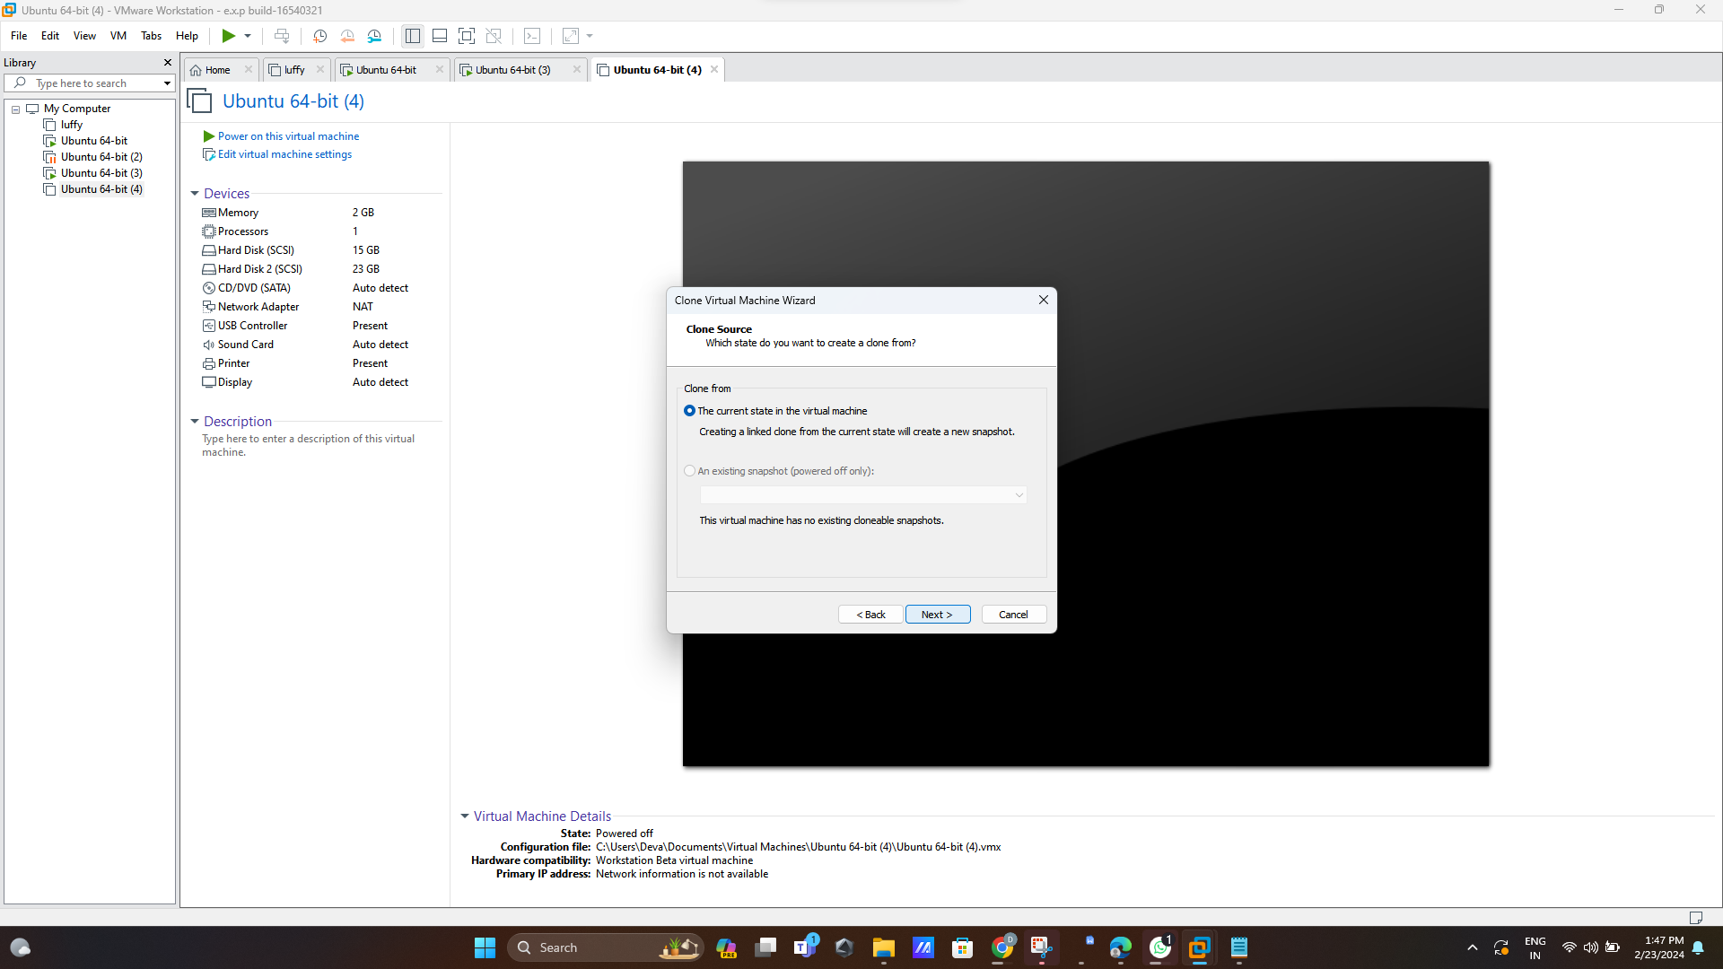

**Step 3:create full clone**

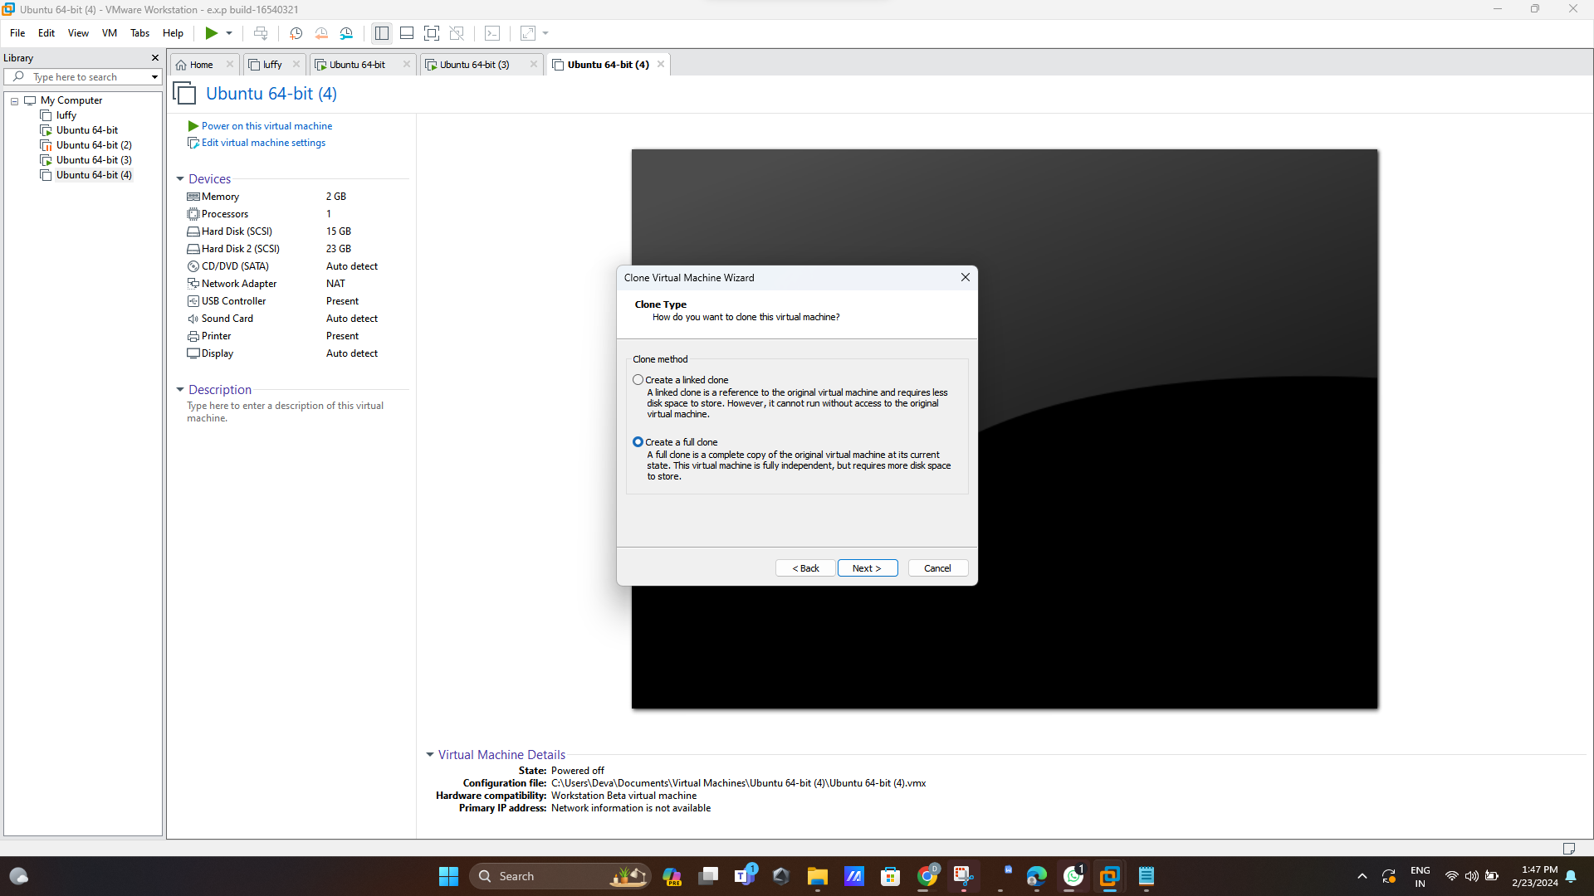

**Step 4:name the clone**

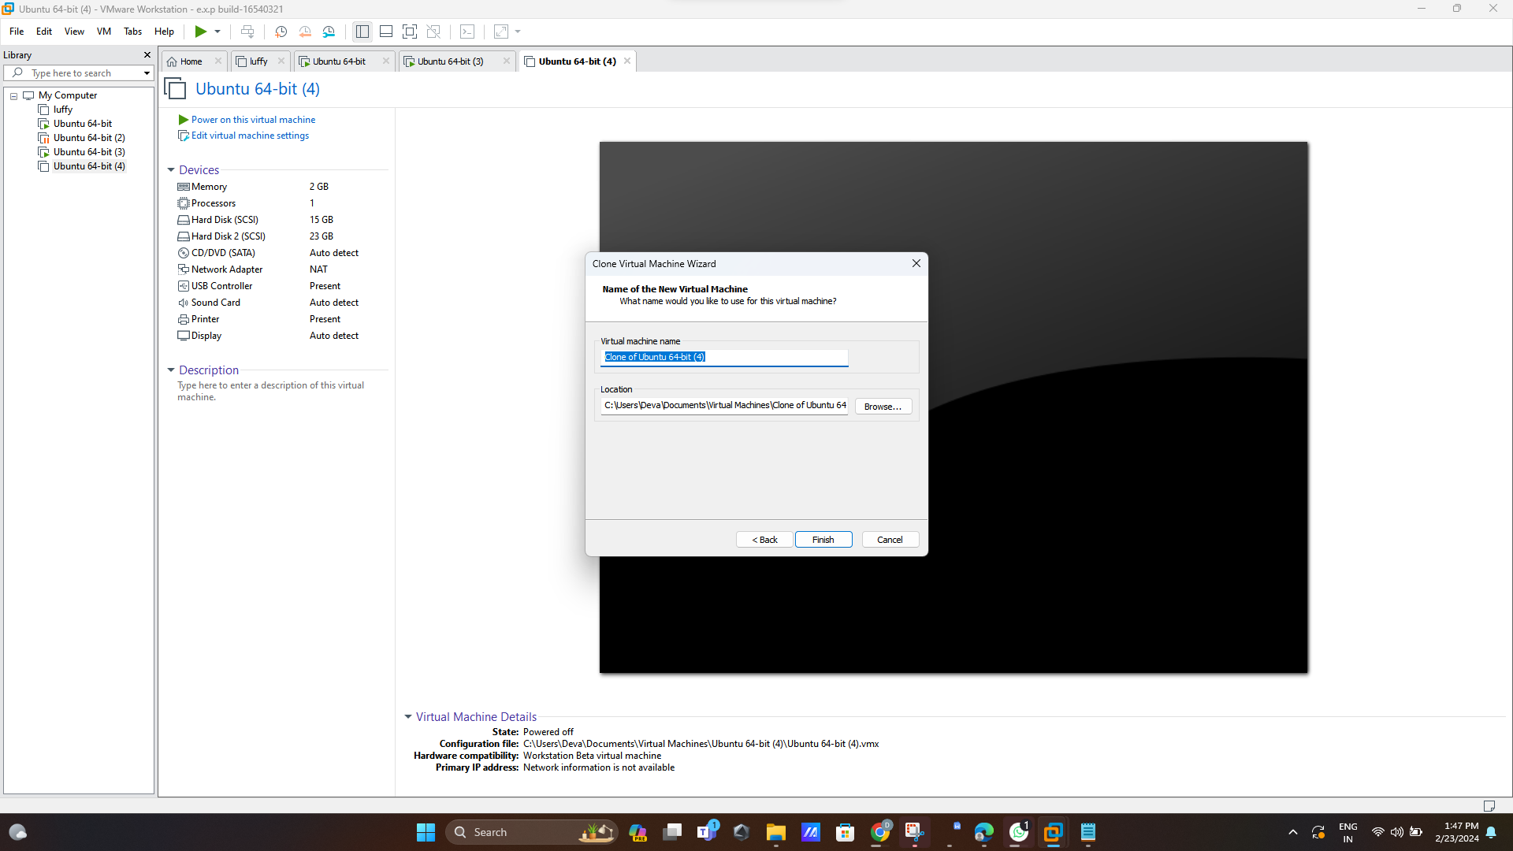

**Step 5:done**

